**Task No. 1:** Write the same program with small variation i.e. this time the program will ask for 3 integers twice and displays the result for each addition separately;

Output will look like as follows:

Enter 3 integers for 1st addition

2

2

2

Enter 3 integers for 2nd addition

3

3

3

The sum of 1st addition is 6 The sum of 2nd addition is 9

**Solution:**

.data

messege1:.asciiz "Enter 3 Digit For First Addition\n"

messege2:.asciiz "Enter 3 Digit For Second Addition\n"

num1: .asciiz "Enter Nulber 1 : "

num2: .asciiz "Enter Nulber 2 : "

num3: .asciiz "Enter Nulber 3 : "

result:.asciiz "The Result of 1st Addition is : "

result1:.asciiz "\nThe Result of 2st Addition is : "

.text

.globl main

main:

li $v0,4

la $a0,messege1

syscall

la $a0,num1

syscall

li $v0,5

syscall

move $t0,$v0

li $v0,4

la $a0,num2

syscall

li $v0,5

syscall

move $t1,$v0

li $v0,4

la $a0,num3

syscall

li $v0,5

syscall

move $t3,$v0

#asdasdasdasdsadasdasdsadasdasd

li $v0,4

la $a0,messege2

syscall

la $a0,num1

syscall

li $v0,5

syscall

move $t5,$v0

li $v0,4

la $a0,num2

syscall

li $v0,5

syscall

move $t6,$v0

li $v0,4

la $a0,num3

syscall

li $v0,5

syscall

move $t7,$v0

#Result 1

add $t4,$t0,$t1

**Output:**

add $t0,$t4,$t3

li $v0,4

la $a0,result

syscall

move $a0,$t0

li $v0,1

syscall

#Result 2

add $t8,$t5,$t6

add $t5,$t7,$t8

li $v0,4

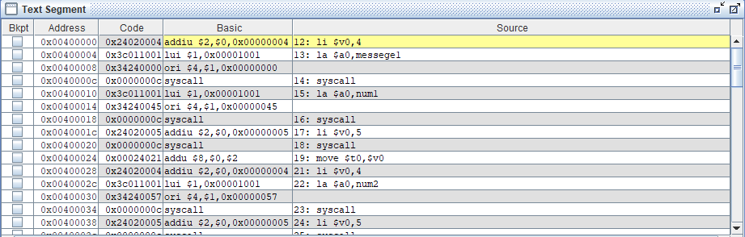la $a0,result1

syscall

move $a0,$t5

li $v0,1

syscall

li $v0,10

syscall

**Output:**

**Task No. 2:** Write an assembly program that Multiply two number within the range of 10.

**Solution:**

.data

into:.asciiz"-------MULTIPLICATION CALCULATOE----------- "

numb1:.asciiz "\nEnter number 1 :"

numb2:.asciiz "Enter number 2 :"

resuult: .asciiz "\nThe Multiplication Of Two Number Is : "

.text

.globl main

main:

li $v0,4

la $a0,into

syscall

li $v0,4

la $a0,numb1

syscall

li $v0,5

syscall

move $t0,$v0

li $v0,4

la $a0,numb2

syscall

li $v0,5

syscall

move $t1,$v0

**Output:**

mul $t3,$t0,$t1

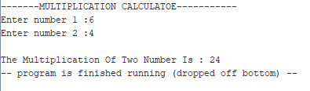li $v0,4

la $a0,resuult

syscall

move $a0,$t3

li $v0,1

syscall

**Output:**

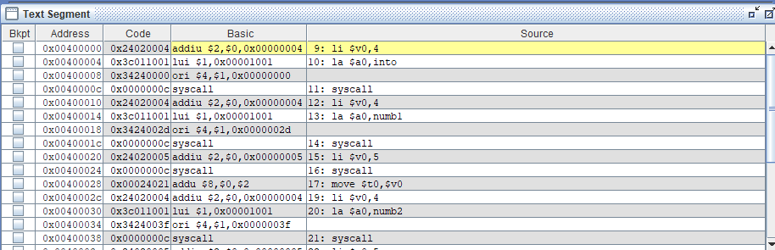

**Task No. 3:** Write an assembly program that Divide two number within the range of 10.

**Solution:**

.data

into:.asciiz"-------MULTIPLICATION CALCULATOE----------- "

numb1:.asciiz "\nEnter number 1 :"

numb2:.asciiz "Enter number 2 :"

resuult: .asciiz "\nThe Multiplication Of Two Number Is : "

.text

.globl main

main:

li $v0,4

la $a0,into

syscall

li $v0,4

la $a0,numb1

syscall

li $v0,5

syscall

move $t0,$v0

li $v0,4

la $a0,numb2

syscall

li $v0,5

syscall

move $t1,$v0

**Output:**

div $t3,$t0,$t1

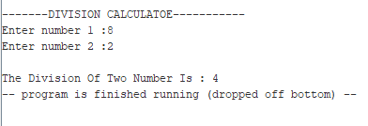li $v0,4

la $a0,resuult

syscall

move $a0,$t3

li $v0,1

syscall

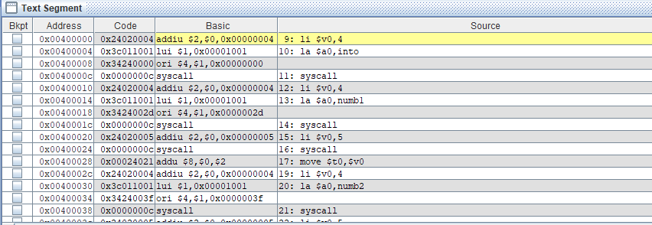**Output:**

**Task No. 4:** Write an assembly program that Read and Print Hello world.

**Solution:**

.data

prompt: .asciiz "Plz Enter Your Message :"

prompt1: .asciiz "\nYour Message is :"

name: .space 26

.text

main:

li $v0,4

la $a0,prompt

syscall

li $v0,8

la $a0,name

li $a1,26

syscall

move $t1,$a0

li $v0,4

la $a0,prompt1

syscall

li $v0,4

move $a0,$t1

syscall

**Output:**

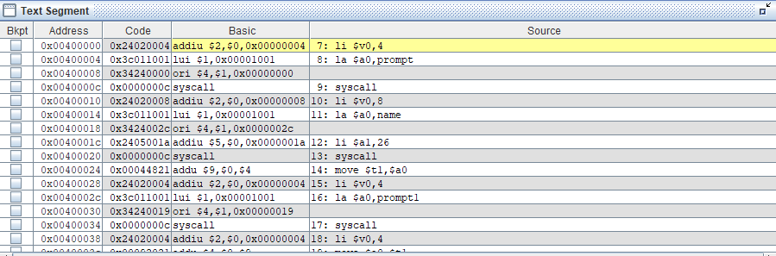

**Task No. 5:** Write an assembly program that add two number within the range of 10. **Solution:**

.data

into:.asciiz"-------ADDITION CALCULATOE----------- "

numb1:.asciiz "\nEnter number 1 :"

numb2:.asciiz "Enter number 2 :"

resuult: .asciiz "\nThe Addition Of Two Number Is : "

.text

.globl main

main:

li $v0,4

la $a0,into

syscall

li $v0,4

la $a0,numb1

syscall

li $v0,5

syscall

move $t0,$v0

li $v0,4

la $a0,numb2

syscall

li $v0,5

syscall

move $t1,$v0

**Output:**

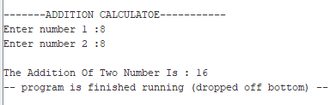add $t3,$t0,$t1

li $v0,4

la $a0,resuult

syscall

move $a0,$t3

li $v0,1

syscall

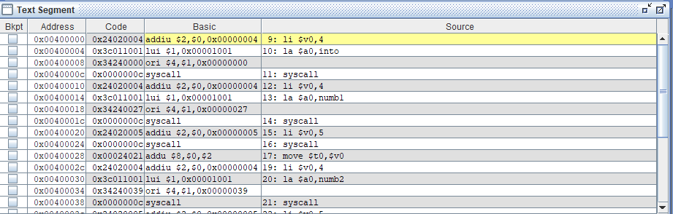**Output:**

**Task No. 6:** Write an assembly program that subtract two number within the range of 10.

**Solution:**

.data

into:.asciiz"-------SUBTRACTION CALCULATOE----------- "

numb1:.asciiz "\nEnter number 1 :"

numb2:.asciiz "Enter number 2 :"

resuult: .asciiz "\nThe Subtraction Of Two Number Is : "

.text

.globl main

main:

li $v0,4

la $a0,into

syscall

li $v0,4

la $a0,numb1

syscall

li $v0,5

syscall

move $t0,$v0

li $v0,4

la $a0,numb2

syscall

li $v0,5

syscall

**Output:**

move $t1,$v0

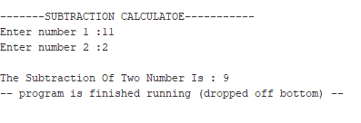sub $t3,$t0,$t1

li $v0,4

la $a0,resuult

syscall

move $a0,$t3

li $v0,1

syscall

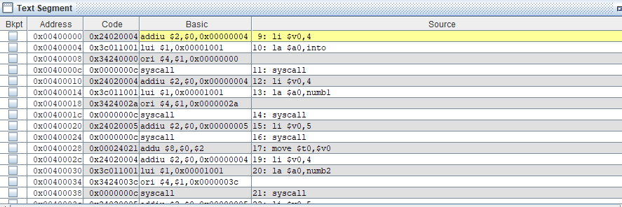**Output:**